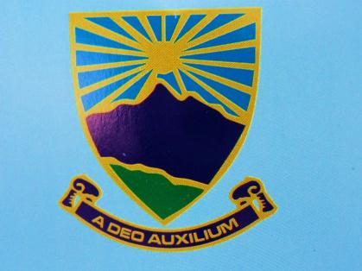
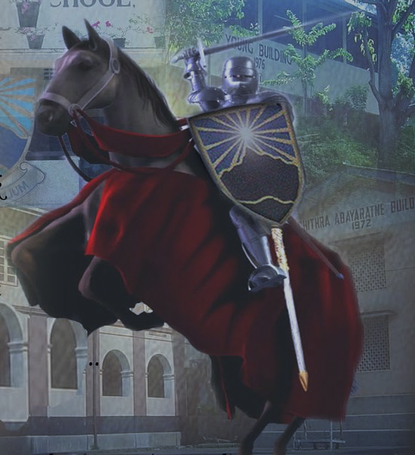
Girls’ High School-Kandy
2012-05-26
The Principal,
……………………………..

Dear Sir/Madam,
“The Battle of Brains 2012”
Invitation
It is with great pleasure that we invite your school to participate in the “Battle of Brains 2012” chess tournament which will be held on the 8th, 9th and 10th of June 2012 at Kandy Girls’ High School. A maximum number of 2 teams can participate in this event from one school. All players should be Under 20 years of age on 1st of January 2012. Please return your entry form on or before the 5th of June 2012. For further information please contact any of the numbers given below. We hope you would all participate in this event and help make this event a great success.

Thanking you,

………………………… …………………………….
(Teacher in charge) (Principal)

Mrs.M.Abeygunasekara(Principal)-0812422884
Mrs.P.Herath(P.O.G.)-071-8248861
Mrs.N.Eriayagama(Teacher In-Charge)-0718248565
Mrs.E.Amunugama(Tournament Coordinator)-071-8298810

